Did you notice that we now have the same problem we had when defining our XHR GET request:

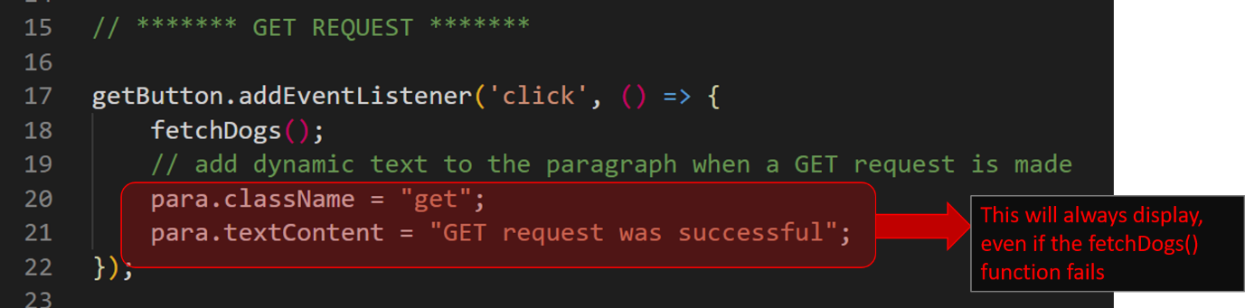
For now I want to leave this and move on.
But don't worry.
In the next section when I show you how to use Axios, in the lecture titled "GET request using Axios" I will show you how to properly set up a callback function with error handling so that if there is an error in making the GET request, the paragraph text does not incorrectly display a successful message.
As a personal challenge, you can use the same code in that lecture to update this fetch request.
Stay motivated, and let's continue to our POST request.

